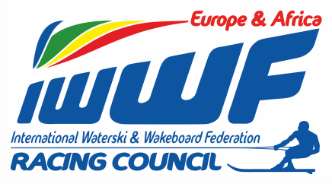 Competitor’s Corner
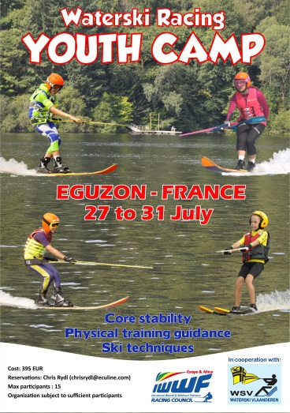

Info - News Bulletin: 4/2015
Youth Camp Eguzon

Dear E&A skiers and teams,

This is a kind reminder informing you once again that the week prior to the Europe Cup final in Eguzon we are organizing the first E&A Youth Ski camp (from July 27th till July 31 st)

A motivated coaching team is looking forward to welcoming the European next generation “ski stars” at this unique location.

The camp will focus on:

- Ski techniques: Wake2wake - stability – paling – tricks - bare-/shoe skiing

- Physical/training guidance: Condition and stability testing, Core training, Gear set up and Race day tips.

Lodging arrangements are not included. If you require assistance for travel and lodging arrangements we will gladly assist in finding a fitting solution.

Registration form can be found on E&A website – Competitor’s Corner.

For any additional information you may require please feel free to contact me via:

Mail : chrisrydl@eculine.com
Phone : #32 479458515

Looking forward to seeing you all at Eguzon

Yours in Water-ski Racing
Chris RYDL

